|  |  |  |
| --- | --- | --- |
|  |  | **School Newsletter 21st August 2023 2023** |
| **Ltyentye Apurte Catholic School**  Church Street, Santa Teresa, PMB 221, Via Alice Springs, NT, 0872.  Tel: (08) 8956 0937 email: robert.dreise@nt.catholic.edu.au |

Dear Families,

**Confirmation**

Confirmation was a BIG success! On behalf of the Ltyentye Apurte Catholic School, I would like to thank parents and carers for preparing the candidates for this very significant sacrament. The students looked very smart, and they represented our community with dignity and respect. A big thank you to Marcus for organising the Confirmation proceedings. Thanks also to Bernice and Kellie for organising the decorations at the church, to JR and Amy for doing the readings, Brother Francis for collecting the cake, Xena and Amy for serving the food and Tony for cooking the BBQ for a very big crowd. Sorry if I missed anyone. A sincere thank you to one and all!

**Have Your Say! Tell Them from Me Survey**

Parents are invited to the school Tuesday, Wednesday, and Thursday afternoon from 2pm to complete a survey. We would like your feedback on Ltyentye Apurte Catholic School and appreciate your thoughts on what we do well and what needs to improve. Come and join us for a cup of tea or coffee and complete the survey.

**FAITH FOCUS**

|  |  |
| --- | --- |
| Pentecost Sunday Holy Spirit 2543301 Vector Art at Vecteezy | Do you pray with self-righteousness, as if you deserve God’s mercy? Do you tend to see God as one Who owes you something? Do you get angry with God when He doesn’t immediately answer your demands? Try to humble yourself and pray for whatever God wants to give to you.  *Most merciful Jesus, I beg of You that I be given only the scraps from the table of Your mercy. I beg this of You with all my heart. Though I do not deserve You, I seek You anyway. You know what I need, dear Lord; please bestow upon me Your mercy for those needs. Jesus, I trust in You.* |

|  |  |
| --- | --- |
| [This Photo](https://en.wikipedia.org/wiki/Geelong_Football_Club) by Unknown Author is licensed under [CC BY-SA](https://creativecommons.org/licenses/by-sa/3.0/) | An **AFL Footy Fun Day** will be held this Thursday. Students are asked to dress up in their favourite footy colours. Activities and games will be held on the oval after lunch. There will be a goal kicking competition, hand pass competition and mini-AFL games. |
|  | **Tell Them from Me Survey**  Staff, students, and parents will have the opportunity to complete a survey this week to give feedback about our school. Your valuable feedback will give staff the opportunity to improve our school. |
| New Xbox Series X + X Box Series S Consoles - JB Hi-Fi | **Fun Zone.**  A wellbeing space has been provided so students have a fun place to go to as a reward when they display our school values of being strong, kind, and respectful. The fun zone has 2 x-boxes, a PlayStation 5, Nintendo Switch, and a ping pong table. The fun zone forms part of our school wide positive behaviour program. |

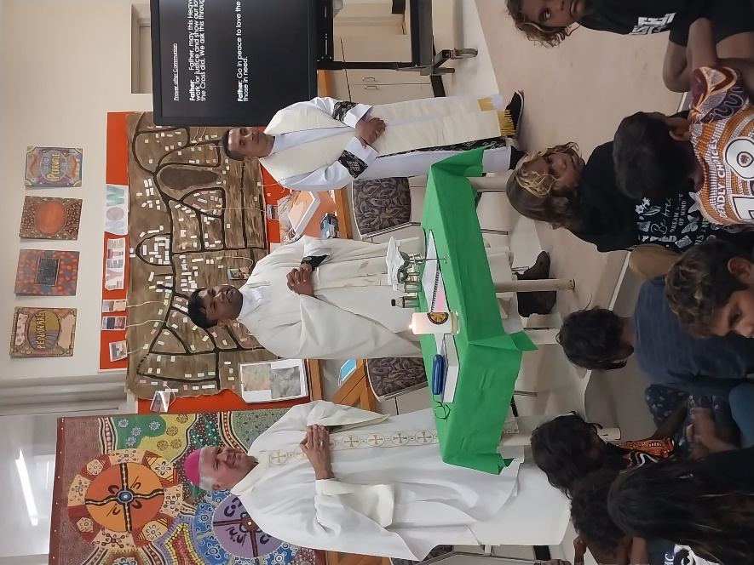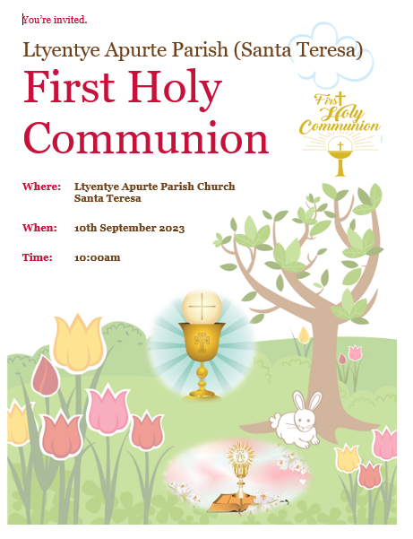

School Mass With

Bishop Charles

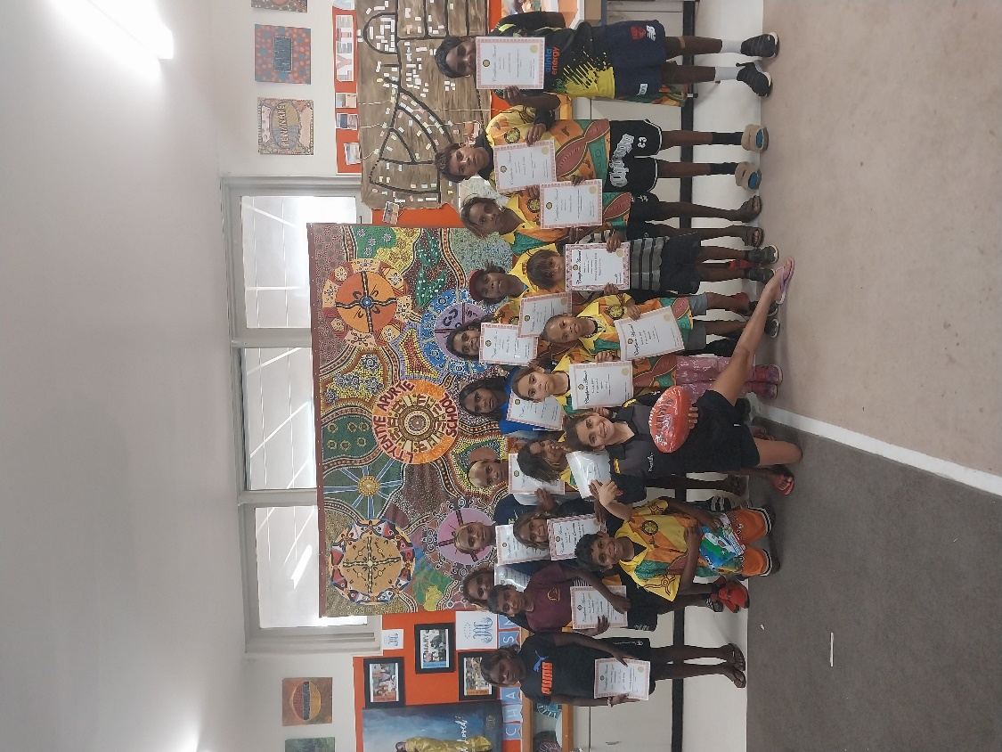

Congratulations to those students who received awards at assembly for displaying our school values of being strong, caring, and respectful.

May God bless our students and families. Have a great week, everyone!

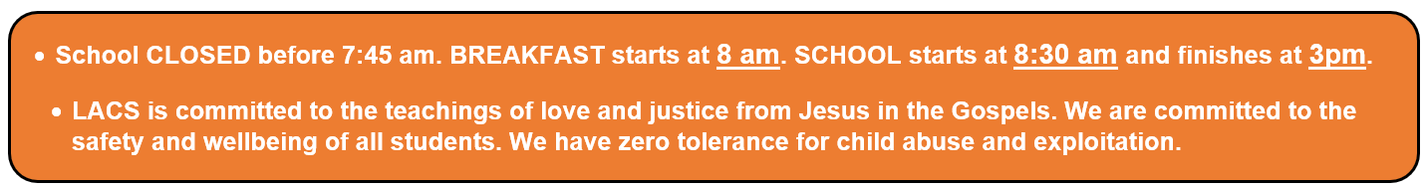

Mr. D

A / Principal

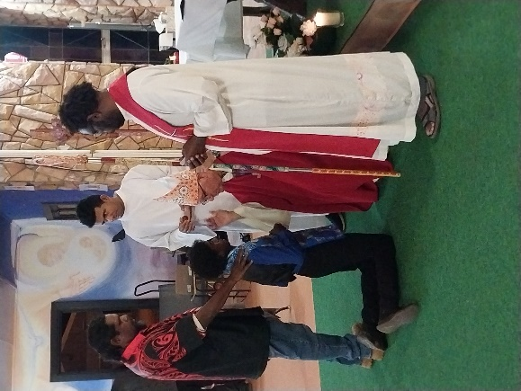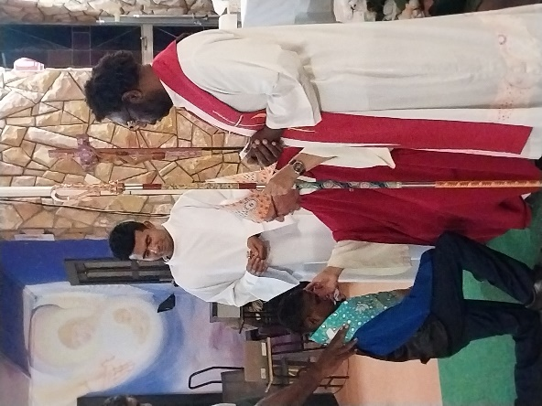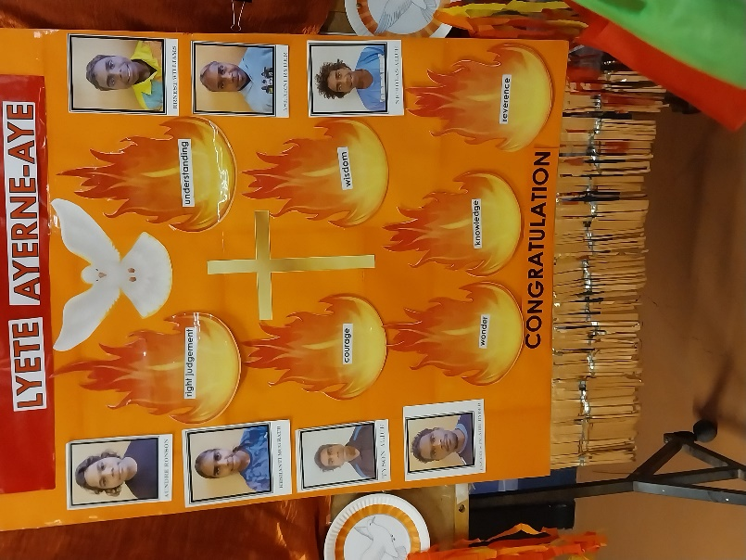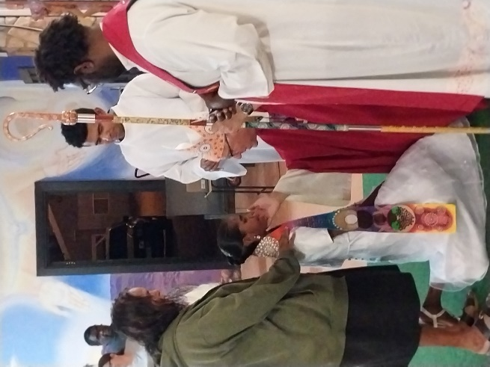

**Confirmation**

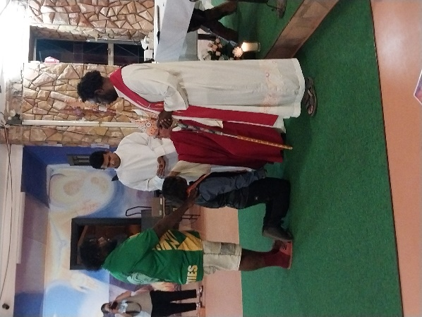

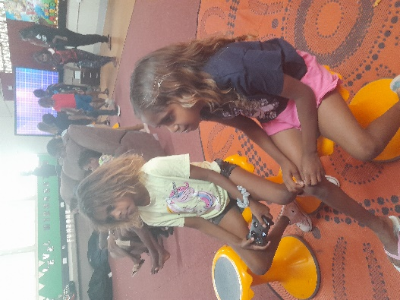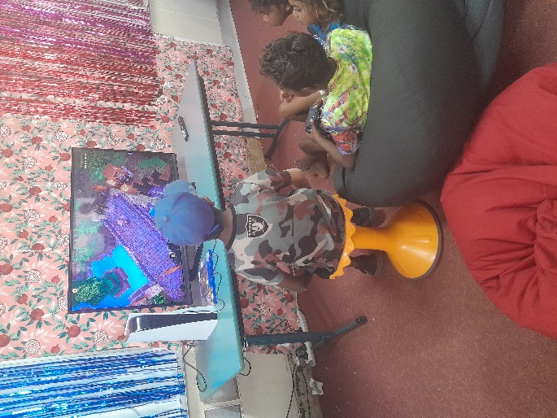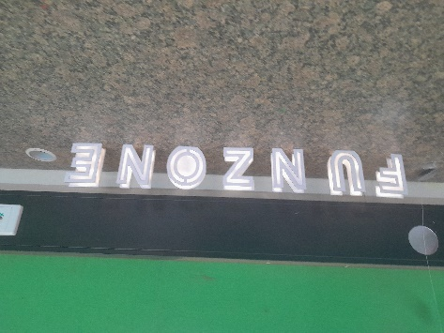



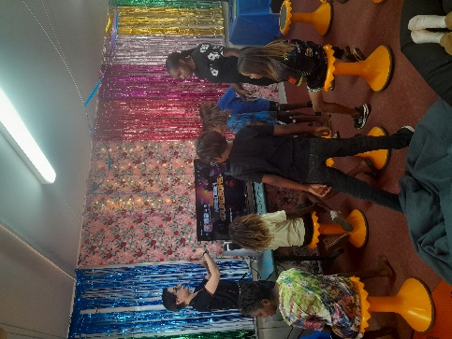





J3 Healthy Eating

Making Rainbow Fruit

